**U.K Road Accident Data Analysis (2021-2022)**

# Introduction

This repository contains data and analysis on road accidents in the United Kingdom for the years 2021 and 2022. The data has been collected from official sources and is intended for research and informational purposes.

## Problem Statement

In the United Kingdom, road accidents continue to be a significant concern, leading to loss of lives, injuries, and economic costs. Despite existing efforts to improve road safety, understanding the underlying factors contributing to accidents and identifying effective strategies for prevention remain critical challenges.

This project aims to analyze road accident data in the UK to:

* Identify trends, patterns, and hotspots of road accidents across different regions, road types, and times of day.
* Explore the factors contributing to accidents, including but not limited to driver behavior, road conditions, weather, and vehicle types.
* Assess the effectiveness of existing road safety measures and interventions.
* Develop predictive models to anticipate and prevent future accidents.
* Provide actionable insights and recommendations to relevant authorities and stakeholders for targeted intervention strategies aimed at reducing the frequency and severity of road accidents in the UK.

By addressing these objectives, this analysis seeks to contribute to the overarching goal of enhancing road safety and reducing the societal impact of road accidents in the United Kingdom.

## Data Sources

* The road accident data (2021-2022) for the UK has been sourced from Kaggle.

### Step Followed

* Step 1 : Load data into Power BI Desktop, dataset is a csv file.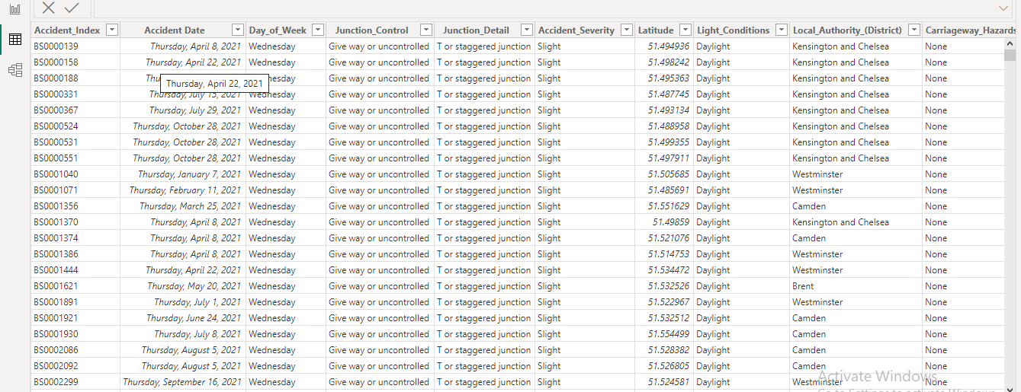
* Step 2 : Open power query editor & in view tab under Data preview section, check "column distribution", "column quality" & "column profile" options.
* Step 3 : In Power Query Editor we also handled missing values appropriately ,and also removed any duplictes values which were there, we also change the data type where ever is required.
* Step 4 : After that it was observed that in none of the columns errors & empty values were present.
* Step 5 :In the report view, under the view tab, theme was selected.
* Step 6 : For calculating number of accidents and casualities in year 2022 we use card.

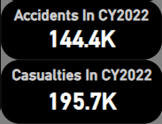

* Step 7 : Similarly we use card for fatal casulaities in year 2022, Slight casulities in year 2022, Total accidents in year 2022.

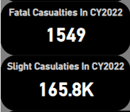

* Step 8 : We used Map Chart to represent area where accidents happens in year (2021-2022).

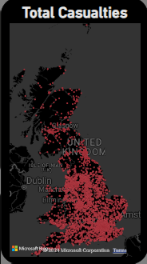

* Step 9 : We used Donut Chart to show and compare the percentage of total accidents happen between rural and urban areas.

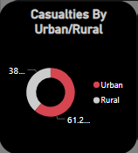

* Step 10 : We used donut chart again to show the percentage of contribution of light condition in accidents we take three kind of light conditions over there -1)Daylight 2)Darkness with light lit 3)Darkness with no lit.

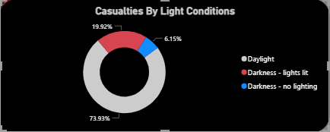

* Step 11 : We made a Area Chart to compare the number of accident in the same month time between year 2021 and 2022.

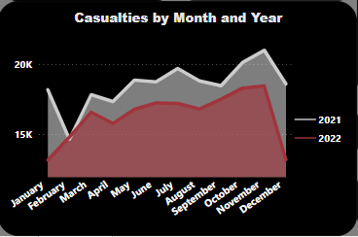

* Step 12 :We also used stacked bar chart to represent casualities by road type. We include road type such as single carrageway, Dual carrageway,Roundabout,Single lane,Slip road.

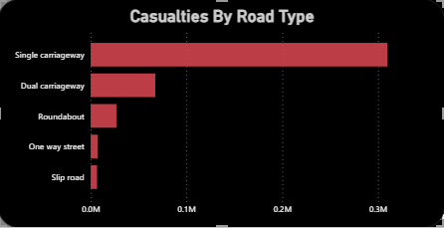

* Step 13 : We used Multi Row Card to represent the contribution of vehicle type in total casualities.

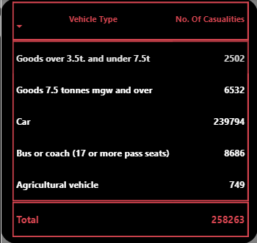

**Dashboard After Completion :**

* After Completion dashboard looks like this.

